- Name of Use Case
Name of the Use Case | IoT platform for Smart Home
Version No. | v0.1
Date | 06/12/2023
Team Members (with student ids) | Ali Mohammad Alizadeh - 308885  Mohammad Eftekhari Pour - 307774  Mahdi Rajaee -  Hamid Shabanipour -
- Scope and Objectives of Function
Scope and Objectives of Use Case
Scope | The proposed IoT platform aims at providing services for a smart home management.
Objective(s) | The expected results consist on providing a smart control of appliances to minimize the energy waste and promoting green behaviours via user-awareness applications.
Domain(s) | Smart home, Smart Building, Smart Grid.
Stakeholder(s) | Home inhabitants, Energy aggregators.
Short description | The proposed IoT platform aims at making smart our homes. It integrates different IoT devices for managing appliances in home environments. It provides control strategies for lighting and heating systems to minimize the energy waste. The overall platform provides unified interfaces (through both REST and MQTT) to integrate the home into Smart Building and Smart Grid environments. Hence, Demand/Response policies can be applied. Finally, the platform provides end-users with detailed knowledge of the household consumption for each appliance.  Summarizing, the main features it offers are:  - remote control of appliances;  - control strategies for lighting and heating systems;  - unified interfaces (i.e. REST Web Services and MQTT queues) available to enable Demand/Response;  - end-user applications for energy-awareness.

- Diagram of Use Case
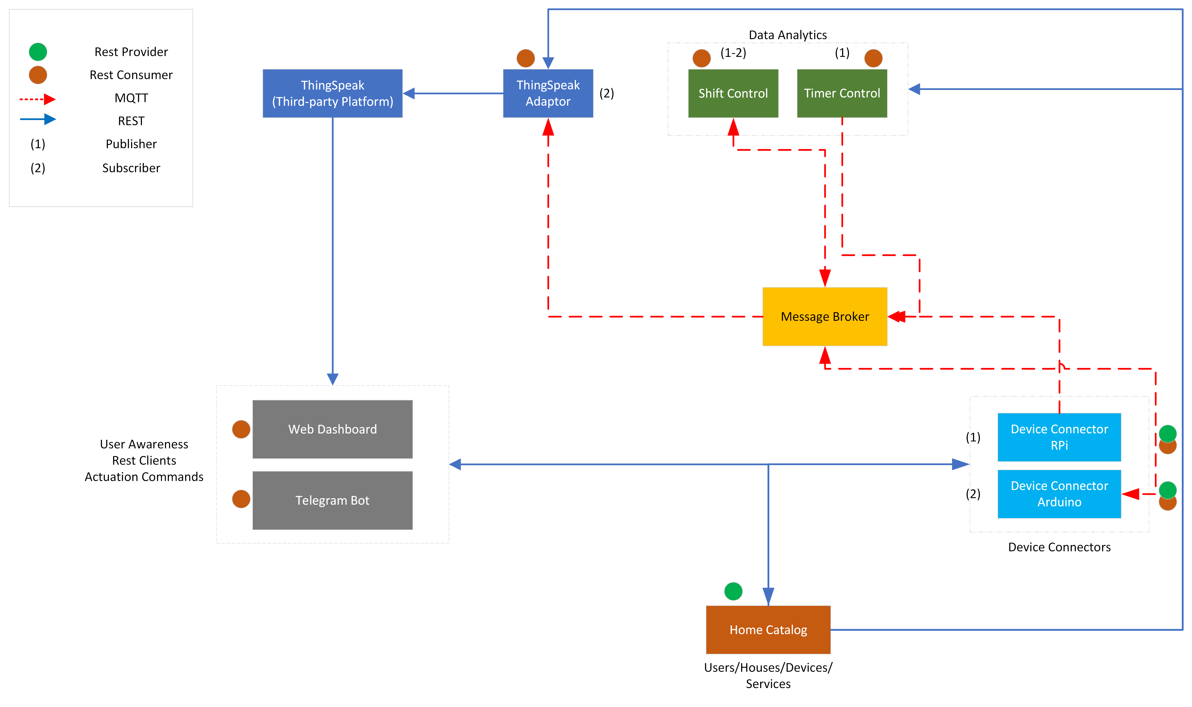
- Complete description of the system
The proposed IoT platform for Smart Home follows the microservices designing pattern. It also exploits two communication paradigms:
- publish/subscribe based on MQTT protocol and
- ii) request/response based on REST Web Services.
In this context, ten actors have been identified and introduced in the following:
- The Message Broker provides an asynchronous communication based on the publish/subscribe approach. It exploits the MQTT protocol.
- The Home Catalogue works as service and device registry system for all the actors in the system. It provides information about end-points (i.e. REST Web Services and MQTT topics) of all the devices, resources and services in the platform. It also provides configuration settings for applications and control strategies (e.g. timers, list of sensors and actuators). Each actor, during its start-up, must retrieve such information from the Home Catalog exploiting its REST Web Services.
- The Raspberry Pi Connector is a Device Connector that integrates into the platform raspberry pi boards. Each raspberry is equipped with motion, temperature and humidity sensors to provide environmental information about the status of a room. It provides Rest Web Services to retrieve environmental information (i.e. temperature and humidity). It also works as an MQTT publisher sending information on user presence (when detected) and environmental data (every 5 minutes).
- The Arduino Pi Connector is Device Connector that integrates into the platform Arduino boards. Each Arduino is equipped with two relays to switch on and switch off the connected appliances. It provides Rest Web Services to retrieve and change the status of the connected appliances (on/off). It also works as an MQTT subscriber to receive actuation commands from other actors that exploit the MQTT protocol (e.g. Control Strategies).
- The Timer Control is a control strategy that manages the lighting system in rooms depending on user presence that can be predicted using thresholds and historical presence patterns and can be adapted using historical data. Each room is managed by an instance of this strategy. It works
  - i) as an MQTT subscriber to receive information on user presence;
  - ii) as an MQTT publisher to send actuation commands to IoT Devices.
- The Time Shift is a control strategy to manage appliances depending on time-schedules provided by the Home Catalog and using an algorithm like moving average and thresholds over the historical data or a ML model which helps the continuous improvements. For example, it allows users to switch on the washing machine from 19:00 to 7:00. It works as an MQTT publisher to send actuation commands to IoT Devices.
- The Thingspeak Adaptor is an MQTT subscriber that receives measurements on environmental measurements and upload them on Thingspeak through REST Web Services.
- Thingspeak is a third-party software (https://thingspeak.com/) that provides REST Web Services. It is an open-data platform for the Internet of Things to store, post-process and visualize data (through plots).
- Web-Dashboard is a dashboard to retrieve data from IoT devices and visualize them exploiting the REST Web Services provided by Raspberry Pi and Arduino Connectors. It also exploits the Thingspeak Web Services to import plots about environmental measurements.
- Telegram Bot is a service to integrate the proposed infrastructure into Telegram platform, which is cloud-based instant messaging infrastructure. It retrieves measurements from IoT devices exploiting the REST Web Services provided by Raspberry Pi and Arduino Connectors. It also allows users on sending actuation commands to IoT devices again exploiting REST.
- Desired Hardware components (only among those we can provide)

Device Name | Quantity | Needed for…

